**Installing and Running the Customer Management CTK**

*[Subtitle]*

**[document number]**

**[Date]**

|  |  |
| --- | --- |
| **Latest Update: [update]** | **[Document Status]** |
| **Version [version number]** | **IPR Mode: [RAND]** |

Notice

Copyright © TM Forum 2015. All Rights Reserved.

This document and translations of it may be copied and furnished to others, and derivative works that comment on or otherwise explain it or assist in its implementation may be prepared, copied, published, and distributed, in whole or in part, without restriction of any kind, provided that the above copyright notice and this section are included on all such copies and derivative works. However, this document itself may not be modified in any way, including by removing the copyright notice or references to TM FORUM, except as needed for the purpose of developing any document or deliverable produced by a TM FORUM Collaboration Project Team (in which case the rules applicable to copyrights, as set forth in the [TM FORUM IPR Policy](http://www.tmforum.org/IPRPolicy/11525/home.html), must be followed) or as required to translate it into languages other than English.

The limited permissions granted above are perpetual and will not be revoked by TM FORUM or its successors or assigns.

This document and the information contained herein is provided on an “AS IS” basis and TM FORUM DISCLAIMS ALL WARRANTIES, EXPRESS OR IMPLIED, INCLUDING BUT NOT LIMITED TO ANY WARRANTY THAT THE USE OF THE INFORMATION HEREIN WILL NOT INFRINGE ANY OWNERSHIP RIGHTS OR ANY IMPLIED WARRANTIES OF MERCHANTABILITY OR FITNESS FOR A PARTICULAR PURPOSE.

Direct inquiries to the TM Forum office:

240 Headquarters Plaza,

East Tower – 10th Floor,

Morristown, NJ  07960 USA

Tel No.  +1 973 944 5100

Fax No.  +1 973 944 5110

TM Forum Web Page: [www.tmforum.org](http://www.tmforum.org/)

Table of Contents

Notice 2

The following section describe how to install the Customer Management CTK.

The Customer Management CTK is dependant on the installation of Newman to work.

The installtion instructions for Newman are found here <https://www.getpostman.com/docs/newman_intro>

Once Node.js and Newmann are installed download and unzip the following [customerAPICTK](http://projects.tmforum.org/wiki/download/attachments/66356062/customerctk.zip?version=1&modificationDate=1467650750613&api=v2) ZIP file within your test directory.

You should see the following files:

-CustomerAPITestCollection.json.postman_collection : the postman collection for the Mandatory tests

-TMFENV : the Environment variable for the REST API Endpoint

Open the TMVENV file and change the following host value to match your endpoint. Note that bu default the environment is pointing

to the Sandbox endpoint.

{

"key": "Host",

**"value": "**[**http://env-0693795.jelastic.servint.net:8080**](http://env-0693795.jelastic.servint.net:8080)**",**

"type": "text",

"name": "Host",

"enabled": true

}

now look for the customerManagementApi key and change it so that it match the URL for the customer resource:

{

"key": "customerManagementApi",

**"value": "{{Host}}/DSCustomerManagement/api/customerManagement/v2",**

"type": "text",

"name": "customerManagementApi",

"enabled": true

}

Save the new values and exit.

Go to your test directory and type the following command:

> **newman -c CustomerAPITestCollection.json.postman_collection -e TMFENV -H customerCTKResult.html -o customerCTKResult.json**

where customerCTKResult.html and customerCTKResult.json will contain the results of the CTK execution.

You should see something like the following:

Iteration 1 of 1

request [object Object]

request typeobject

201 651ms POST /customer <http://env-0693795.jelastic.servint.net:8080/DSCustomerManagement/api/customerManagement/v2/customer>

✔ Content-Type is present application/json

✔ Status code is 201

✔ Response contains ID 13208

✔ Response contains HREF

✔ POST Body Response equals Request Body

....

201 187ms POST /customer copy <http://env-0693795.jelastic.servint.net:8080/DSCustomerManagement/api/customerManagement/v2/customer>

✔ Content-Type is present application/json

✔ Status code is 201

✔ Response contains ID 13263

✔ Response contains HREF

✔ POST Body Response equals Request Body

200 62ms /current copy <http://env-0693795.jelastic.servint.net:8080/DSCustomerManagement/subscriber/api/current>

204 67ms delete hub by id copy <http://env-0693795.jelastic.servint.net:8080/DSCustomerManagement/api/customerManagement/v2/hub/13262>

✔ Successful DELETE request13262

Summary:

Parent Pass Count FailCount

-------------------------------------------------------------

Folder customer test 18 0

Folder hub test 8 0

Total 26 0

If they are no failures then you have passed the CTK and your API is conformant with all

the Mandatory features.

The results of the CTK are in the customerCTKResult.html abd should look like.

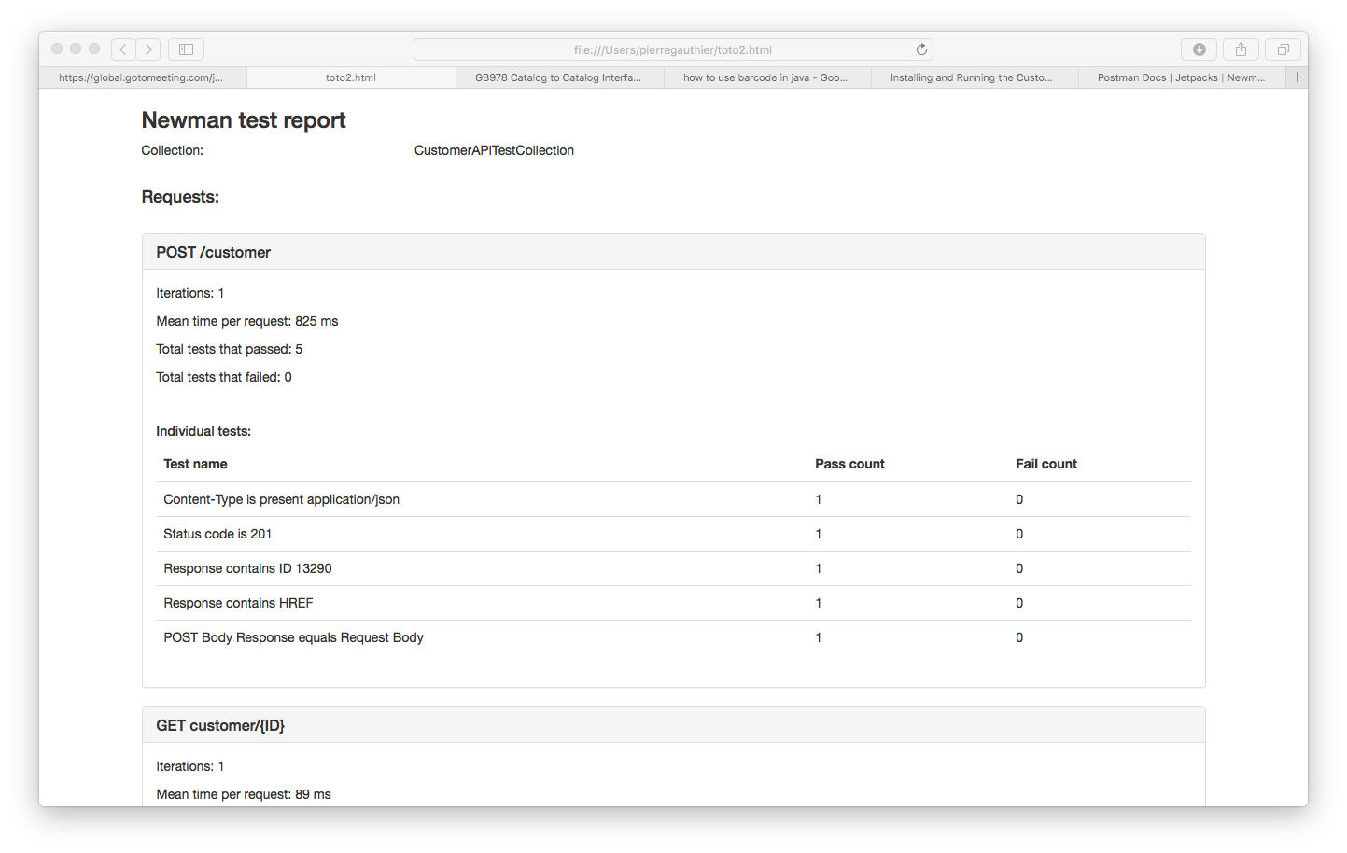

Figure 1 CTK Results

While all the information related to the execution of the CTK will be contained in the customerCTKResult.json file.